Multi Factor Authentication Instructions

GCOA will soon require multi-factor authentication (MFA) in order to access the Court's resources. Earlier this year you were encouraged to enroll one of several second factors in preparation for this transition. <S:\1 - IT TRAINING\MFA Enrollment >The initial rollout will allow users to choose one of three second factor methods, which are explained in detail at the end of this document:

- One Time Passcode
- SMS Message
- Smartphone

The instructions below will provide an overview of how to go through the MFA sign-on process. The screenshots show the steps to sign into the Docket on a desktop browser. While the view will be slightly different when accessing other resources or on another device (Like a mobile phone or iPad), the steps are the same.

- Enter your username and password, then click "Sign in"

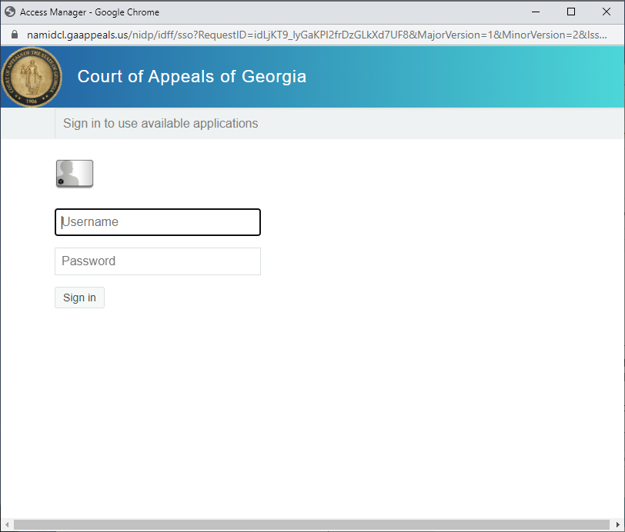

- Choose one of the MFA methods from the dropdown below. You will only see options here for methods you've previously enrolled. Once you've selected an option, click "Next" to continue.

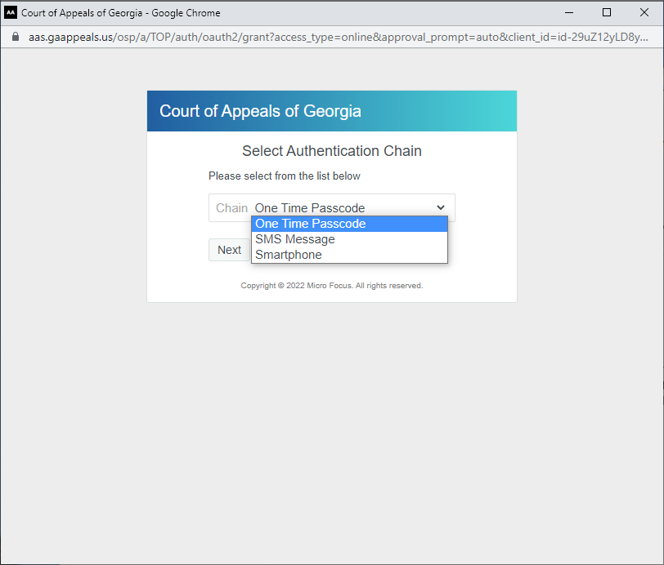

- You will be prompted to enter the One Time Password (OTP) code, which will be delivered to you via whichever method you chose in the previous step. Enter in the code and click "Next" to continue.

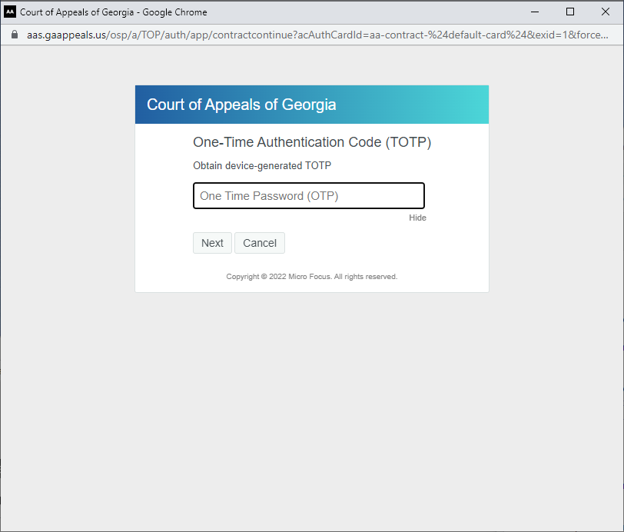

- Once the code is entered in, you'll be redirected to the landing page of the resource you were logging into. For example, if you logged into the Docket and went through the previous steps, you would arrive on the main menu page as shown below:

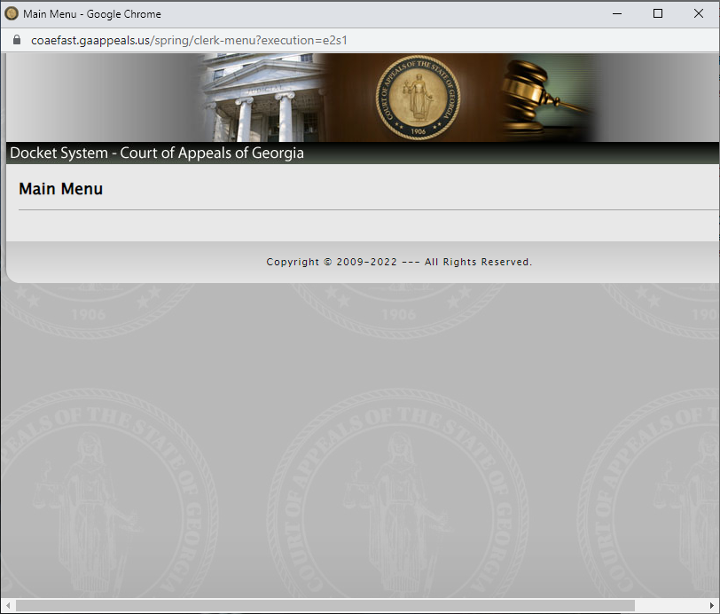

Second Factor Methods Explained
This section outlines the details of the second factor methods and what their individual log in flows will look like.

One Time Passcode
This method enables you to authenticate using a time-based-one-time password (TOTP). The TOTP is generated on the NetIQ Advanced Authentication app. Take the code generated in the app and enter into the box asking for the One Time Password.

The code is valid for a short time before changing, and the time remaining before the code changes is shown in the app, as shown in the screenshot below:

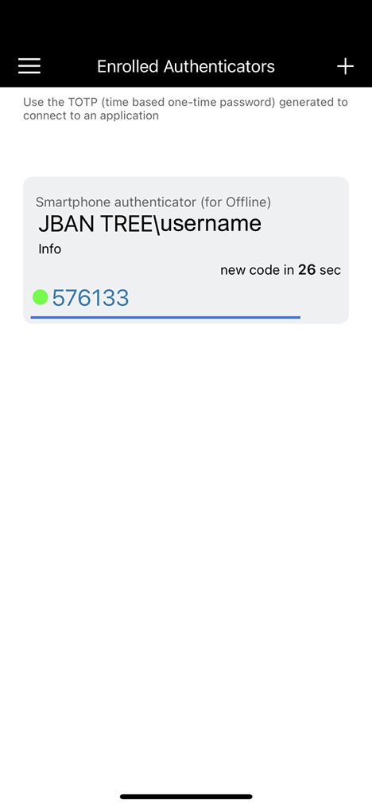
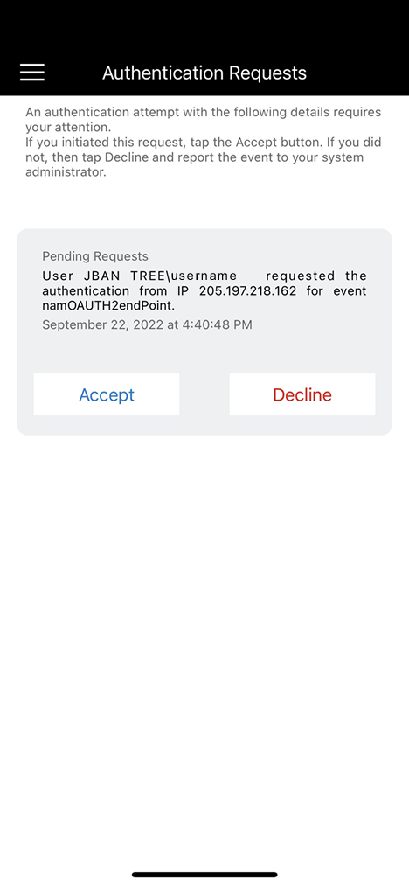

SMS Message
This method generates a password that is sent via text message to the phone number you enrolled. Once you receive the text message with the code, enter the code into the box asking for One Time Password, as shown below:

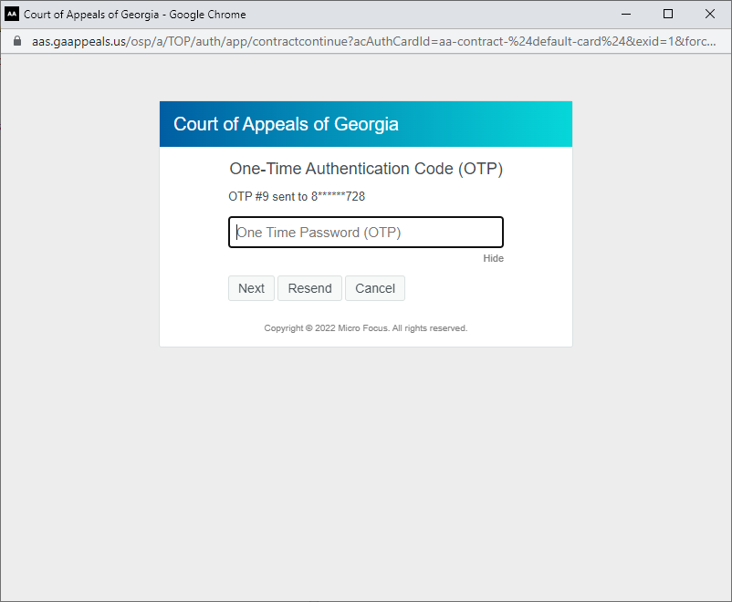

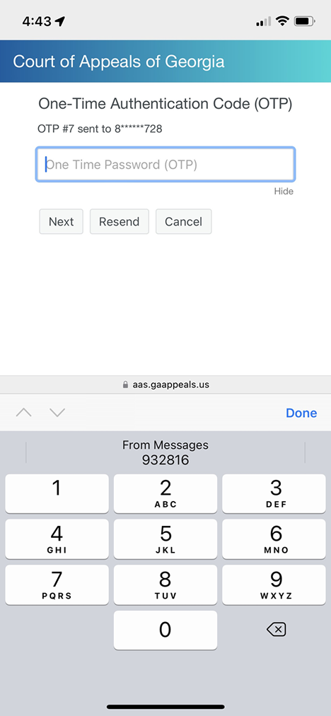

Smartphone
This method uses the NetIQ Advanced Authentication App. When the device on which this app has been installed is connected to the internet, a push notification with Accept or Reject buttons is displayed and a tap is all that is required to confirm your second factor, as shown below.

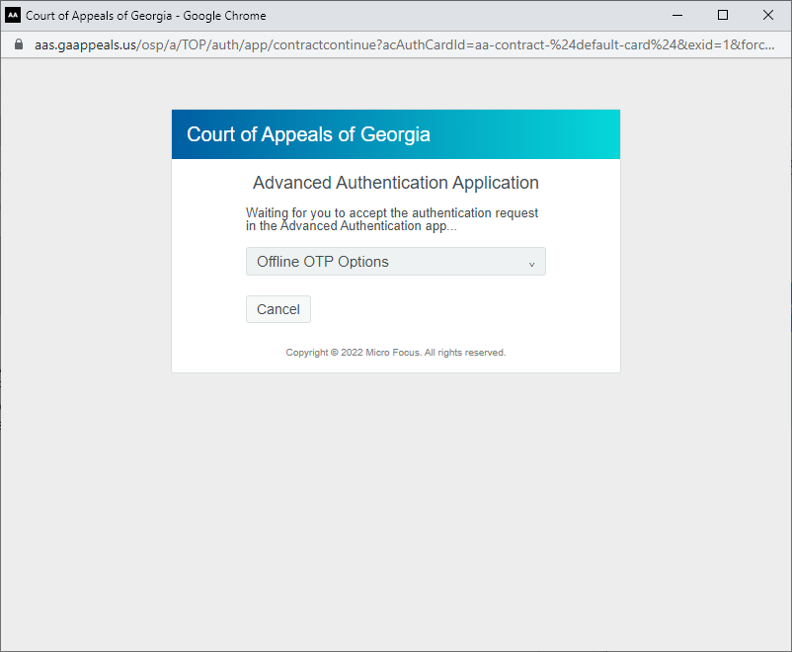

The Smartphone method can still be used to provide a second factor even when offline. Click the "Offline OTP Options" dialog to display an additional field for entering the offline code displayed in the app.

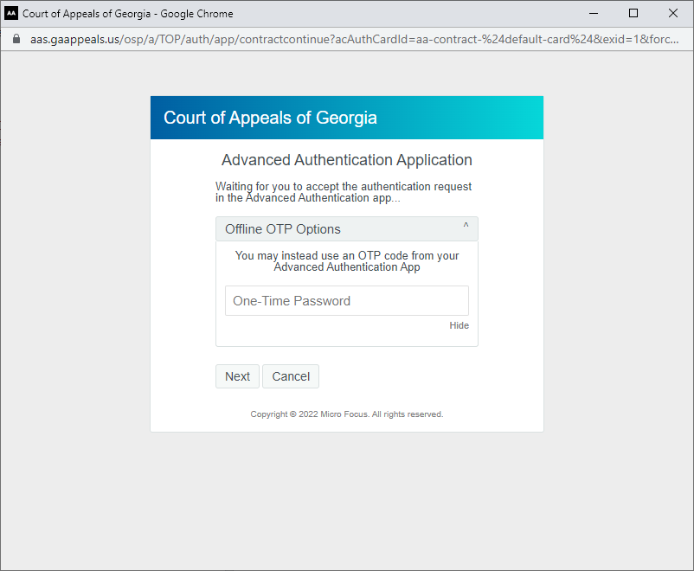

FAQ
- What happens if I have not yet configured a second factor?
  - After providing your network username and password a message is displayed indicating the same along with a link to the enrollment page.

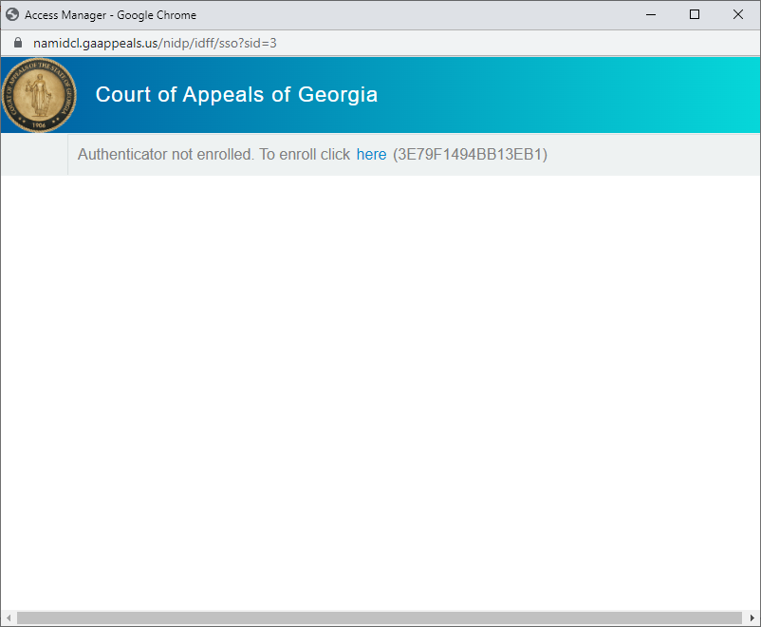

Instructions for registration for iPhones and Androids can be found at S:\1 - IT TRAINING\MFA Enrollment.

- Why do I not see all three options?
  - You have not yet registered for each. Access the enrollment site (https://aas.gaappeals.us/account) to configure additional methods.

